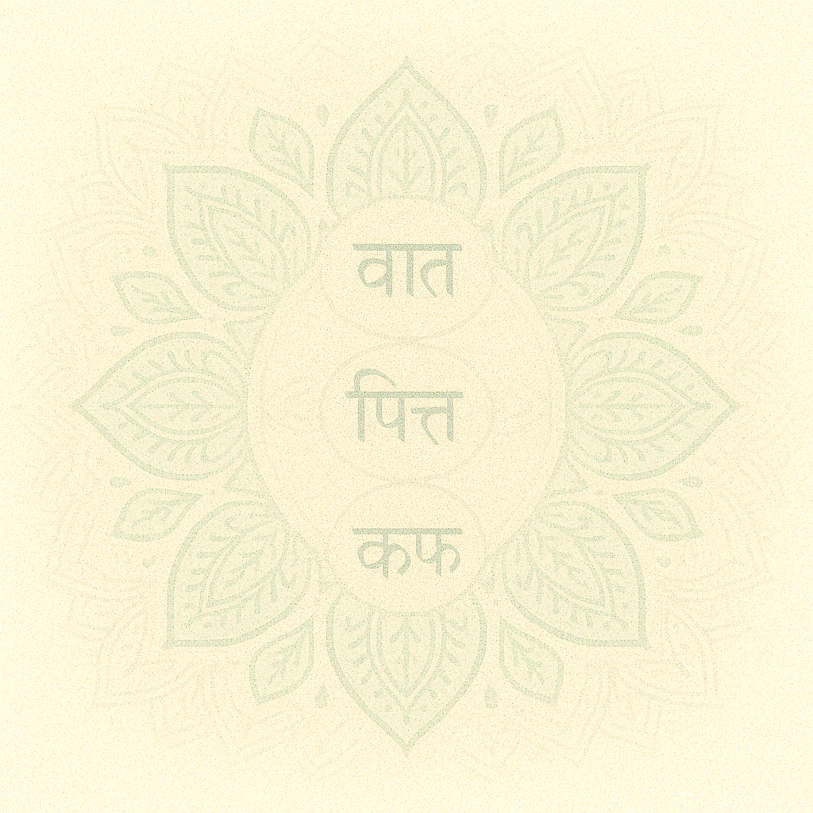
Ayurveda That Changed Lives in the UK – Now in India!
Experience the Power of Ayurveda with a Scientific Edge
Maya’s Ayurveda
Dr. Maya Parikh (B.A.M.S, N.D.D.Y, HCPC-UK BMS)
A unique blend of tradition and technology - because your health deserves the best of both worlds.
With 35+ years of clinical experience, Dr. Maya integrates traditional Ayurveda with modern biomedical science. Thousands of patients in India & the UK have found holistic healing.
We Fully Treat the Diseases in Trend – Treated over 25000 patients:
Hormonal Imbalance, Menopause, PCOD, Physical and mental health care for women aged 55 and above, Fibroids, Infertility, Pre and Post Conception Care, Thyroid, Periods Problem, Anaemia, Diabetes, Blood Pressure, High Cholesterol, Anxiety, Migraines, Sleep Apnea, Cancer, Thyroid, Weight Imbalance, All Types of Allergies and Skin Diseases, Arthritis, Siatica (Back Pain), Cervical Issues, Post Sport Injuries Treatment Care, Weak Immunity, Worms (Gut Biome), Lack of Growth, Asthma, Weak-Memory, Anaemia.

And Many More…
What to Expect from Your Consultation:
- In-depth review of lifestyle, diet & wellbeing
- Complete health assessment
- Customized Ayurvedic + Biomedical treatment plan
- Guidance to restore balance & vitality
Book Your Consultation Today (Online consultations available)
Call Us: 8780493489 or Visit: www.mayasayurveda.com

Clinic Timings
Monday to Friday
- Morning: 10:00 AM – 12:30 PM
- Evening: 5:00 PM – 7:00 PM
Saturday
- Pre-booked appointments only
Sunday – Closed

